HOROWHENUA A P & I ASSOCIATION

HOME INDUSTRIES SECTION

HINTS FOR EXHIBITORS

In the presentation of this information the Ladies Committee of the Home Industries Section of the Horowhenua AP & I Show hope it will help exhibitors to be conversant with basic skills and details looked for by our Judges.

The Committee and Stewards are always willing to assist exhibitors with any problems relating to exhibiting.

Accept the Challenge – Give it a Go

This information was compiled by the Home Industries Committee.

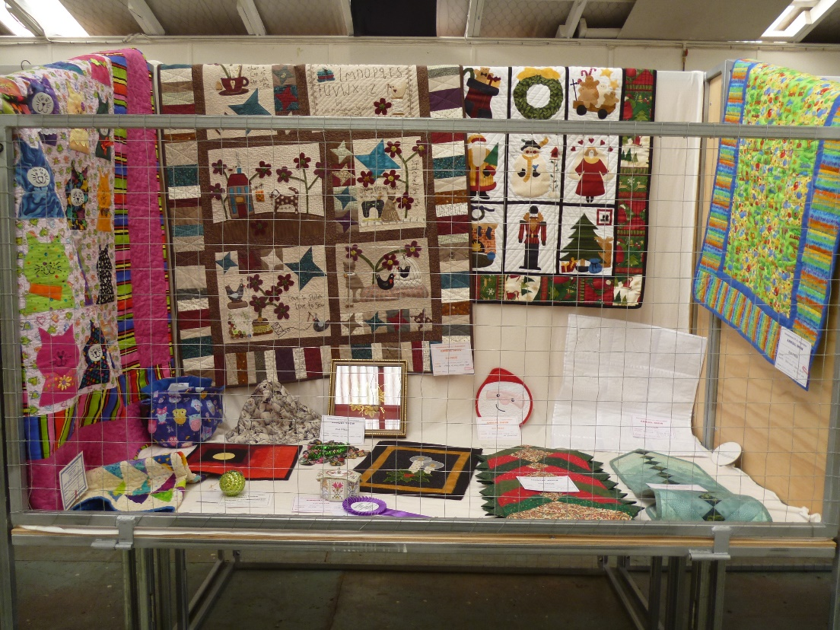
COOKING

1. Be completely conversant with Schedule i.e. number of items.
2. Presentation important.
3. Rack marks on cakes not acceptable.
4. Icing sugar sprinkled or dusted on entries not acceptable, unless
stated.
5. Where Schedule states iced cake – plain and even icing required.
Fork marks allowable.
6. When number of items is stated – all should be uniform in size, shape
and colour.

Pikelets
May be round or oval shaped. Golden brown colour and breaks
easily when folded.
Gems
Must be cooked in gem irons. Slightly rounded.

Loaves
If Schedule states fruit only – don’t put in nuts. Loaves must be well
risen.

Queen Cakes
Tops should be rounded – not iced. Sultanas or currants may be
used. Made in patty tins or paper cases
Cup Cakes
Tops should be rounded in paper cases and iced.

Madiera Cake
Round tin. Only flavouring is lemon. 2-3 pieces of lemon peel
allowed on top.
Sponges
Well risen, no cracking. Layers must be even size.
Fruit Cakes
Well risen with a flat smooth surface. Sides even and corners well
squared. Fruit evenly distributed, maybe round or square.

Biscuits
Uniform size and crisp.
Shortbread
Must be either pricked or stamped
Pale smooth uniform colour
Fine even texture
YEAST COOKERY

1. Yeast products must not have other raising agents.
2. Exterior:- a) Good even shaping
b) No cracks
c) Thin crust
d) Well risen
3. Interior:- a) Colour must be true according to type of bread
b) Moist and soft but not doughy

Pastry
1. Tart – an open pastry base containing sweet or savoury filling. May
have lattice work on top.
2. Flan – an open pastry base – savoury or sweet filling.
3. Pie – must be covered with pastry.
a) Double crust pie i.e. pastry top and bottom
b) Single crust pie – top layer of pastry only.

PRESERVES & JAMS

1. Containers
a) Jars for jam no smaller than 350gms
b) Jelly in jelly jars or tumbler i.e. straight sided jar
c) Clean jars essential
d) Jars must be labelled and dated
2. Preserved Fruit
a) Quart size jar or equivalent
b) Screwbands must be removed
c) Clean jars essential
d) Jars must be labelled and dated
e) Pack fruit neatly
f) No stalks, pips or stones
g) No sediment, discolouration or air bubbles
h) Liquid must cover contents
3. Jam
a) Jam must be filled to top with no more than 5mm headspace
b) Jam should move but not run when jar is tilted
4. Jellies
a) Jellies must be clear
b) When a jar of jelly is tiled the jelly should bulge but not break
5. Marmalade
a) Fruit must be sliced not minced.

PICKLE RELISH CHUTNEY & SAUCE

1. Containers
All containers should be clean, labelled and dated

2. a) Sauce should be in a bottle
b) Relish )
c) Pickles ) in relevant jars
d) Chutney )

3. Sealing
a) Wax may be used
b) Plastic screw cap with or without wax disc

4. All sauces, pickles, chutney and relish should be mature i.e. 6 weeks
old

5. Pickles
a) A 10mm space between pickle and lid
b) Fruit or vegetables should be movable

6. Relish
a) Well cooked ingredients, should still be identifiable
b) Relish should flow

7. Chutney
a) Chutney should be smooth – no skins, cores, stones or pips

8. Sauce
a) Must be smooth and pourable
b) Bottle filled to within 10mm of top

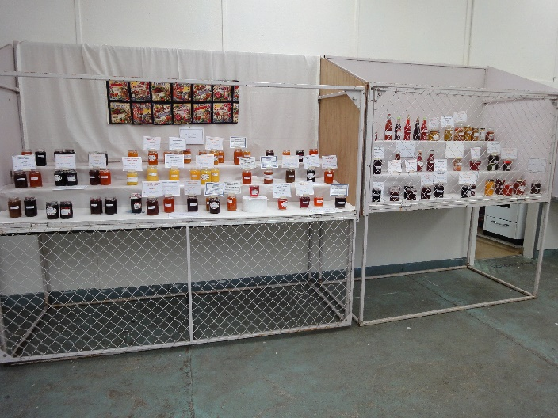
NEEDLEWORK & CRAFT SECTION

Needlework
1. Even weave fabric with thread to suit.
2. Must not be pulled i.e. stitch must be square.

Patchwork
1. Piecing should lie flat.
2. Thread should be neatly and securely fastened.

Doilys
May be pinned out to keep pattern shape for final press.

Sewing
1. Neat even seams and darts.
2. Overlocking acceptable.
3. Trim selvages off all fabrics.
4. Use of polyester thread advisable.
5. Use same stitch length throughout the garment or article.
6. No loose threads or ties. Knot them and trim excess off.
7. Zip plackets must be flat and the zip slides easily.
8. Match all stripes and patterns.
9. All garments must be cut on the correct grain of fabric.
10. Do not overpress.
11. When Schedule states machine made garment/article – hand
finishing/sewing allowed.

Soft Toys
Toys may be knitted, crocheted or sewn.
1. Toys should be safe for babies and toddlers.
2. Hand worked faces. No removable hard trim.
3. Fabric chosen should be non-flammable.
4. Firmly and evenly stuffed.

Hand spun
Presentation
1. Wool should be presented in a skein – ends tied together and
twisted.
2. Evenly spun and plied unless otherwise state.
3. Wool must suit article or garment i.e. soft wool for children, medium
wool for outwear, coarse wool for rugs etc.
4. The twist and fibre should be even throughout the skein.
5. When sewing up all seams should be flat and not pulled too tight
Weaving
1. Weaving should be firm
2. Should lie flat
3. Colours and patterns in proportion
4. Even beat and tension
5. Neat finishing

KNITTING & CROCHET

1. Suitability of yarn to pattern
2. Choose your yarn carefully – better quality yarn gives a better result
3. Correct needles for thickness of yarn to keep an even tension
throughout the garment or article
4. Do not have knots in rows
5. When sewing up all seams should be flat and not pulled too tight
6. Always sew on buttons using same yarn. Strand yarn if necessary
7. All seams at cast on edge must be even
8. Fair Isle – Do not carry wool across back of work too far. Twist wool
every second stitch
9. Unless it states other finishing allowed, crochet should not be used
10. Pressing – be advised by the label on the yarn.
11. Buttonholes must be evenly spaced
12. Neckbands – Must be flexible to slip overhead comfortably
13. Cast on edges should be even – not too tight or too loose
14. Loose ends/threads must be removed

Bootie & Baby Garments

1. Remember booties are generally for small babies
2. No bulky seams
3. All bands must be flexible
4. Open pattern often not suitable
5. When knitting babies cardigans and jersey, armholes should not be
too tight

COURTS

1. Be completely conversant with Schedule
2. Be sure the theme tells the story
3. Use of too many extra props not advisable
4. Clutter often detracts from items. Judge must be able to see all
Items
5. Focal Point – very important
6. Co-ordination of colours important
7. Good size proportion of exhibits to each other
8. Identification cards – not too conspicuous
9. Food should be placed in appropriate position e.g picnic food in/on
containers, on cloth or similar. Interior scene not on floor
10. Container of sweets – container and sweets judged

